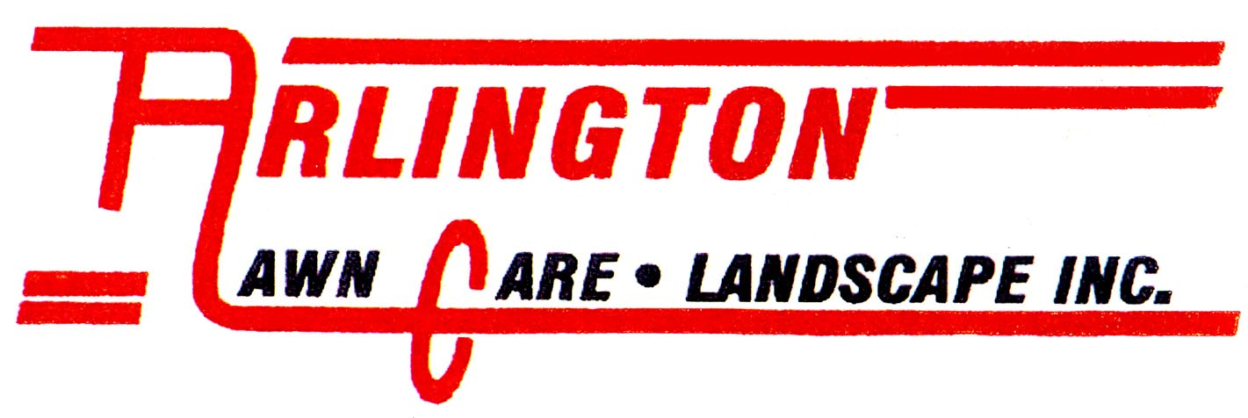
8501 OLD FRENCH ROAD

ERIE, PA 16509

PHONE 814-864-2586 ● FAX 814-866-8952

WWW.ARLINGTONLAWNCARE.COM
ANYTHING WORTH DOING IS WORTH DOING RIGHT!
1-866-454-0948

About the CSP Program  CERTIFIED SNOW PROFESSIONALS (CSP) PROGRAM  In a continuing effort to increase the professionalism already put forth by our membership, SIMA is proud to introduce this Certification Program. The objectives of the Certification Program are: | 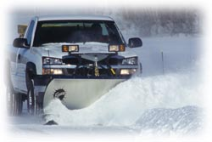
- To raise the standards of the profession.
- To encourage self-assessment by offering guidelines for achievement.
- To identify persons with acceptable knowledge of principles and practice of the profession.
- To award recognition to those who have demonstrated a high level of competence in the profession.
- To improve performance within the profession by requiring participation in a continuing program of professional and educational development.
- To cooperate with other providers of educational services in the development of training programs and continuing education and/or review of applicable programs.
About the Certification Process
Before a person can take the exam, they must meet stringent requirements. Both formal education and work experience are taken into consideration. The exam application requires the submittal of a written letter of reference from the applicant's present employer in the case of an employee of an in-house operation or a snow contractor, and four (4) reference letters in the case of a business owner taking the exam. These referenced people shall be sent a confirmation questioner. At least two of the references must respond to the conformation questioner in order for the candidate to be eligible to take the exam. If negative response is received, it shall be investigated by the Board of Governors. Furthermore, the Board of Governors reserves the right to perform any investigation it deems necessary in order to determine eligibility for any applicant to take the exam.

Exam Subjects
The CSP exam is structured to take approximately six hours and a score of 70% or greater in each section is necessary in order to become certified. The exam covers major areas of importance to those in the snow and ice management business. Listed below are the various sections of the exam.
- Snow Science
- Snow Mechanics
- Corporate Finance
- Marketing
- Law
- Human Resources
Use of CSP Designation
Certification is for individuals only. The Certified Snow Professional (CSP) designation may be used only after the name of the certified individual. In this form, it may be used on letterhead, business cards, brochures, advertisements, all forms of address etc. The CSP designation may not be used to imply that a firm is certified. Upon successfully passing the exam, a Certification Plaque and Official CSP Stamp are provided to the CSP.
Continuing Education
Certified Snow Professionals are required to continue their education in order to stay abreast of developments in the industry as well as general business practices and professionalism.
Some examples of how Certified Snow Professionals continue their education and dedication are:
- By attending SIMA Annual Snow & Ice Symposium.
- Attending Industry trade shows with educational sessions.
- Attending business and industry related educational seminars.
- Speaking publicly or organizing formal educational sessions for others in order to educate them about business and/or the snow and ice industry.
Code of Ethics
Certified Snow Professionals must adhere to a higher standard than most within our industry. To this end, all applicants shall be required to agree, in writing, to adhere to these high standards of ethics when dealing with customers, employees, subcontractors, vendors, suppliers and competitors. Failure to adhere to such standards, or conduct in a manner inconsistent with the high standards and goals of the Certification Program may result in the Board of Governors revoking the Certification of the offending individual. All applicants shall be advised of this section prior to acceptance of the application for testing.

